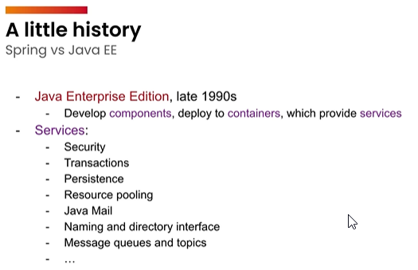

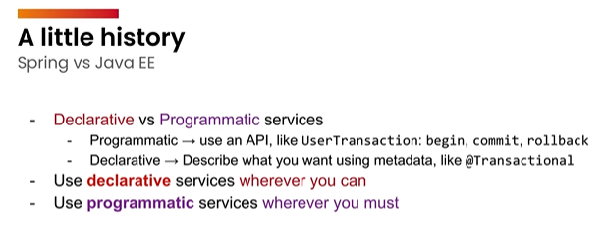

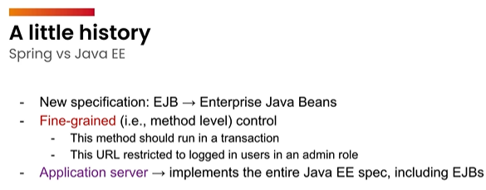

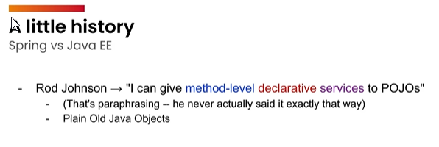

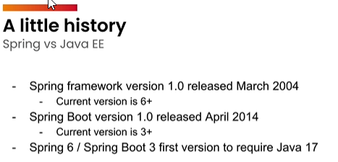

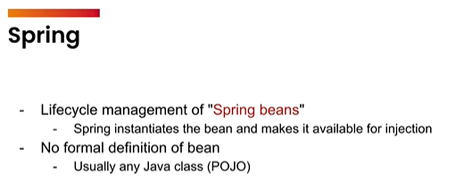

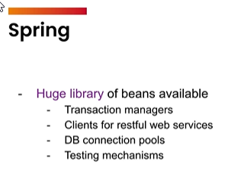

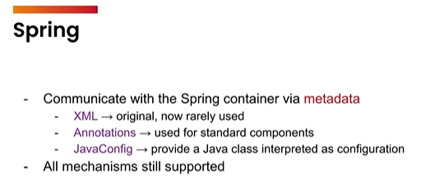

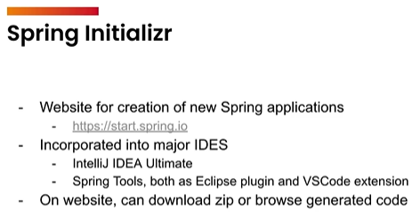

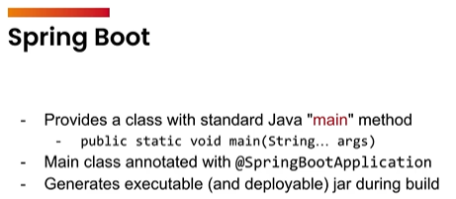

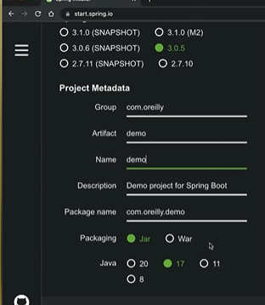

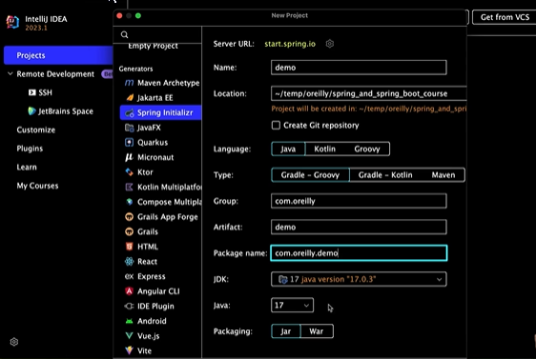

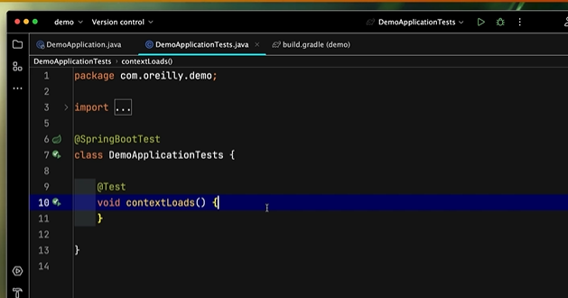

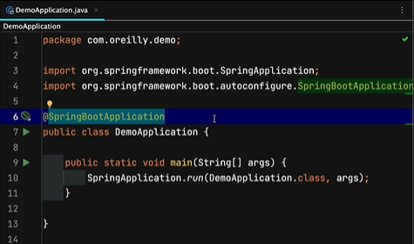

Component Scan starts here, since SpringBootApplication is defined here. Important we define the controller under this root package

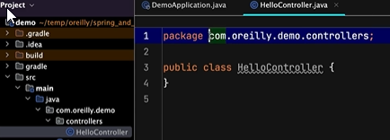

Controller: Receives a HTTP request and they either return a HTTP response or return you to a view somewhere.

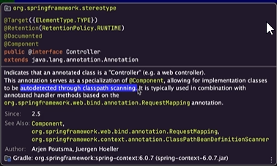

Need a way of connecting a particular URL(HTTP request) to a method.

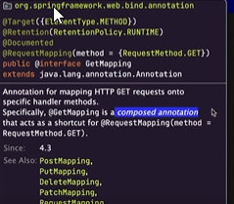

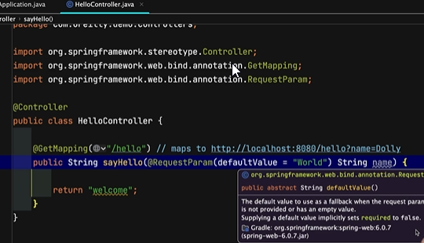

Model: Basically a Map, collection of keys and values, Spring will take it, add it to the current HTTP request and forward it to some view.

When url goes to /hello after the default localhost:8080, then it should invoke the sayHello function.

Name is an optional argument, since default is given.

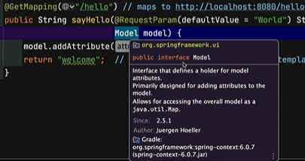

Model is an interface, yet we are calling addAttribute, so there must be some class which implements it.

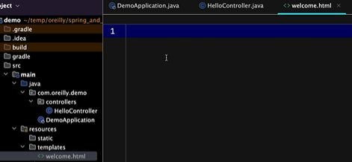

Add the file in templates folder.

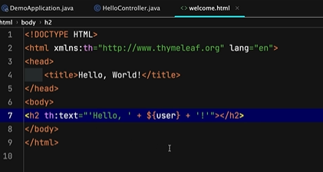

The text here, comes from Thymeleaf.

User variable here, is the exact same thing as the user variable inside the model.



Now in Controller, welcome no longer shows a warning.



Thymeleaf syntax gone. Template Engine.



Another way to do this.

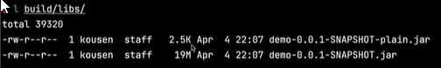

The one that is more size, 19M, is our deployable .jar file.





Another way to run the same app.





Special command

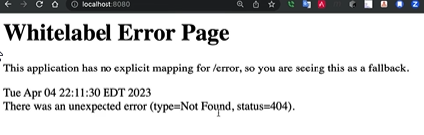

But if we just go to localhost: 8080, we get a error message.



We create the index.html page on static folder which isn’t going to be changed on a request to request basis.

In templates, it might be different on every single request, might be different name each time.

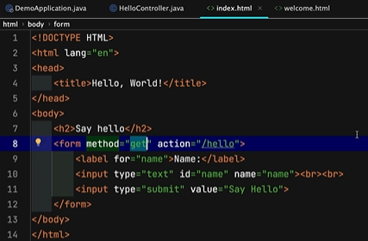

Form, GET request



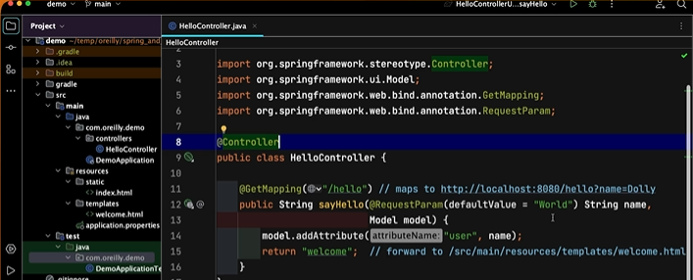

Alt+Enter: Create a Test

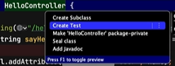

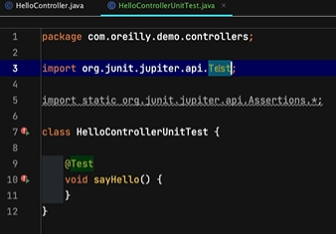

Same Package where the controller exists.

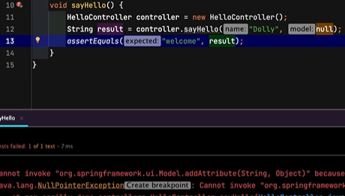

Null Pointer Exception

AI suggested code.



BindingAwareModelMap() implements the Model

Check returned and expected values.

In the same Controller package.

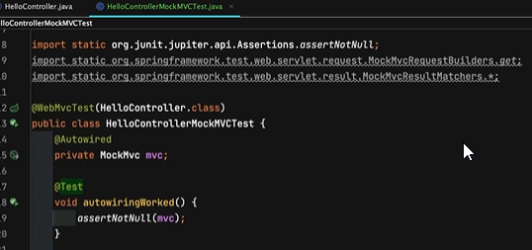

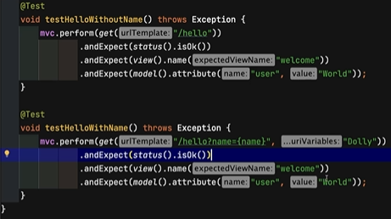

Put together a trivial, restful web service, only going to respond to GET requests, but it will give us back an object and we can serialize that object to JSON data, JavaScript Object Notation data.

Controller package, Hello REST Controller

With regular Controller, we redirected it or forwarded it to a view, with REST controller, we will return a object, which will automatically get serialized into JSON Data and dumped into the output stream automatically.

Record: from java 17, data holder, allows us to put data in an object that we normally call a POJO, but it has got a ton of auto-generated code in it.

Immutable: Once you have instantiated a record, you can never change a message.



